OPENERP THUNDERBIRD PLUG-IN USER GUIDE

Starting with Thunderbird plug-in, first of all you need to set the configuration settings of OpenERP.

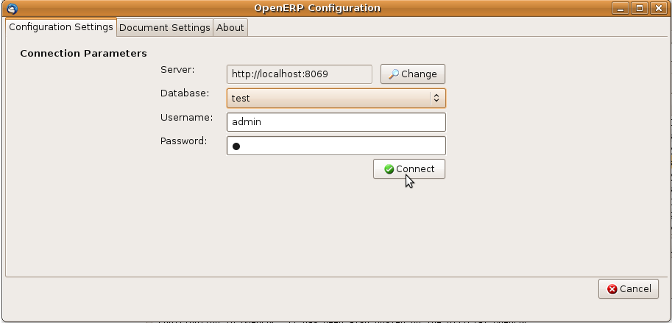
How to set the configuration of OpenERP in thunderbird ?
- From Menu Bar, Open Tools -> OpenERP Configuration
- In “Configuration Settings” tab, default values for the server path, port, database name, username and password will be set for the localhost.
Note:- Be sure OpenERP Server is running
- Click on “Test Connection” to check whether the username and password you have entered is correct or not.
- If we can change the server name and port so click on change button.
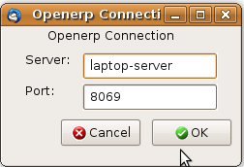

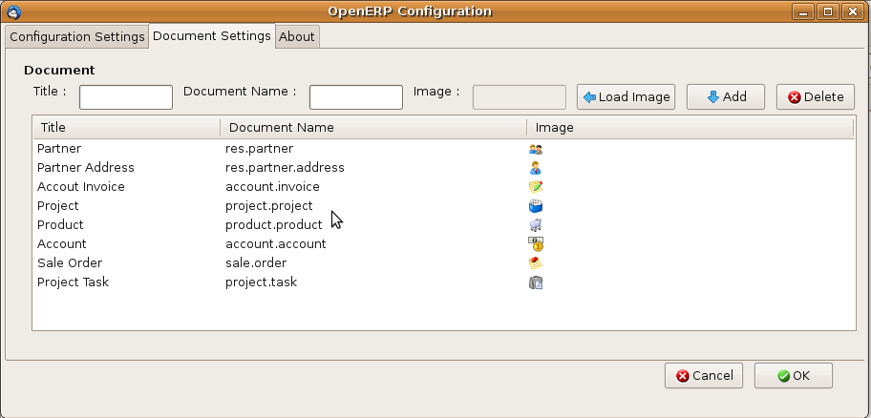
- In “Object Settings” tab, default list of objects will be set.
- If you want to add new object then write the object name that exist in OpenERP and than click on “Add Image” to select the image.
Note :- For better visualization use small size image (16 x 16 or 32 x 32)
- Click on “Add ” to set that object and image in the list of objects.
- For deleting the existing object, select one of the object from the list of objects and click on “Delete”.

How to use Thunderbird plug-in to archive your emails to OpenERP ?

1. Searching the records from OpenERP
For archiving your selected email to OpenERP, select the email from the list of emails .Then Click on
From Menu Bar, Open Tools-> Archive To OpenERP or Select “Archive To OpenERP” in Mail Toolbar.

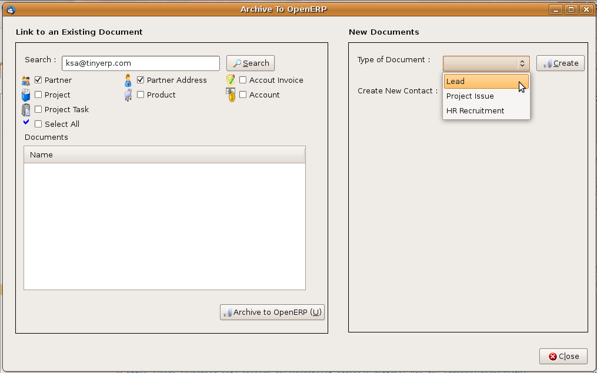
In this new window the text box contains the email id of the sender of the email. Now the no. of checkbox depends on the list of objects present in the Configuration settings. Now select one of the checkbox and click on “Search” and this will try to search in OpenERP for the value in the text box for a particular object. This will try to search for the name field if any, in all the objects .

It also shows the list of records found in OpenERP on the basis of the value in the text box. We provide multi functional search feature by selecting multiple checkbox. To identify the records according to the object we provide the image according to the checkbox image which is basically the image in the configuration settings.

2. Archiving email to the Selected Record of OpenERP
For archiving email to selected record of OpenERP, select one or more
records from the list of the records and click on “Archive To OpenERP”.

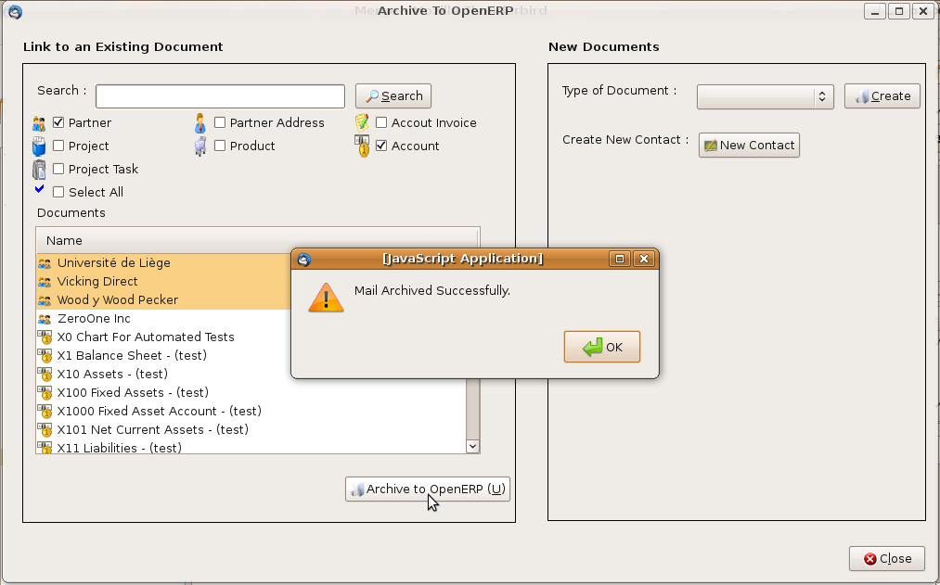
If you create any new document so select any one document in the dropdown list and click on create button.Document create successfully.

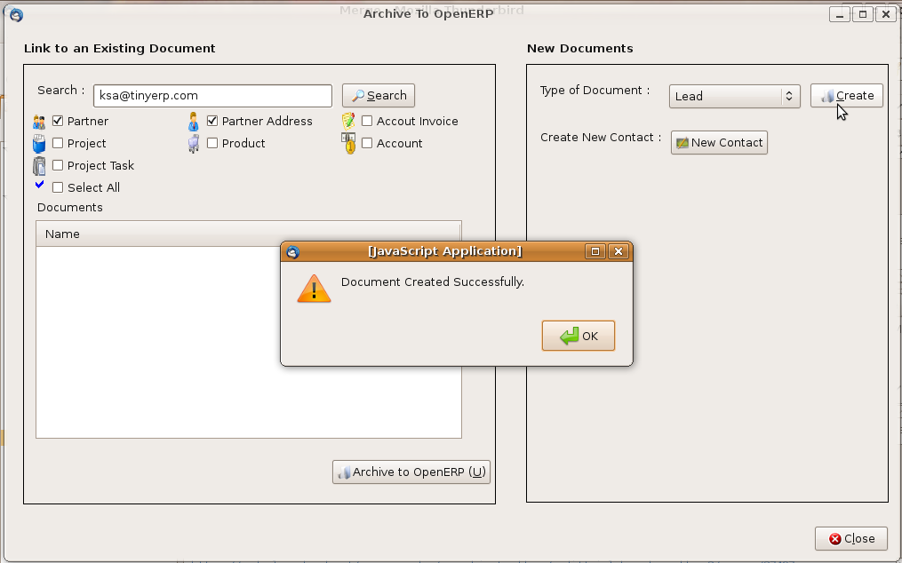

3. Creating a Contact to archive email to OpenERP
If while searching it fails to show the records than you can create your own contact in OpenERP with which you can archive your email.

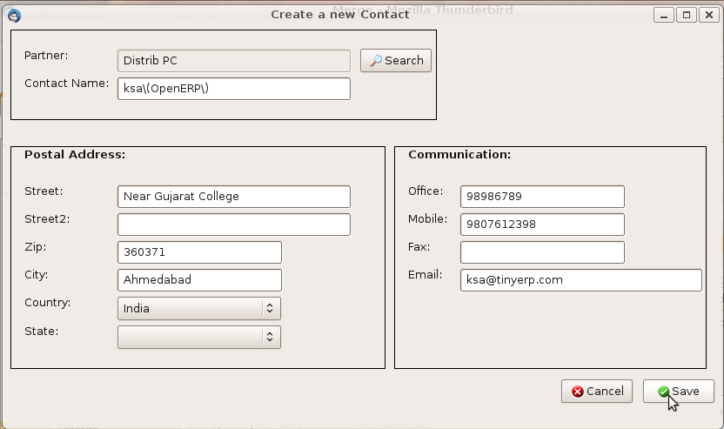
In the above window the list box contains the name and email of the sender of the email and even the text box contains the same. The other text box, which are not compulsory field. But the text box select partner which is read only, has to be filled. To fill the partner value search for the partners existing in OpenERP or you can create a new partner, it is explained below. If u not define Partner contact is also created.

While you click on “Search” a new window will appear where you can search for the existing partners in OpenERP.

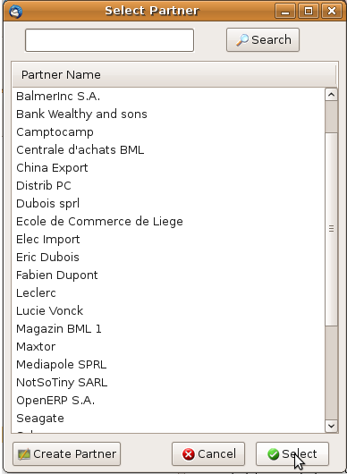

If the partner of whom you want to archive the email does not exist you can create a new partner. For that click on “Create Partner” and a new window will appear where you need to write the name of the partner and click “Ok”.

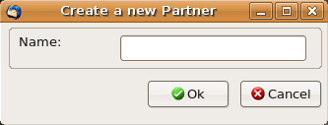

While you click on “Ok” and if the partner with the same name exist in OpenERP than it will show an alert window that the “Partner Already Exist”.

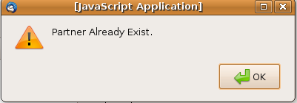
Now after creating a new partner select the partner in the list box and click on “Select” to select the partner for which you want to create a contact in OpenERP.

When You Update Contact Detail Click on Open Contact Button From Toolbar.

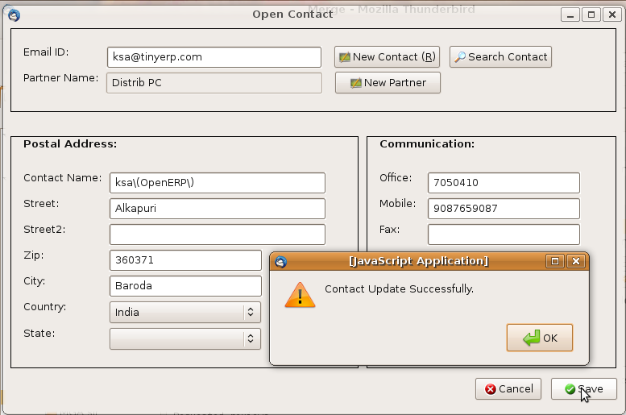

Enjoy Archiving the Thunderbird Email to OpenERP

